Deformable Linear Objects Dataset and Evaluation

Bardia Mojra, William J. Beksi, and Nicholas R. Gans

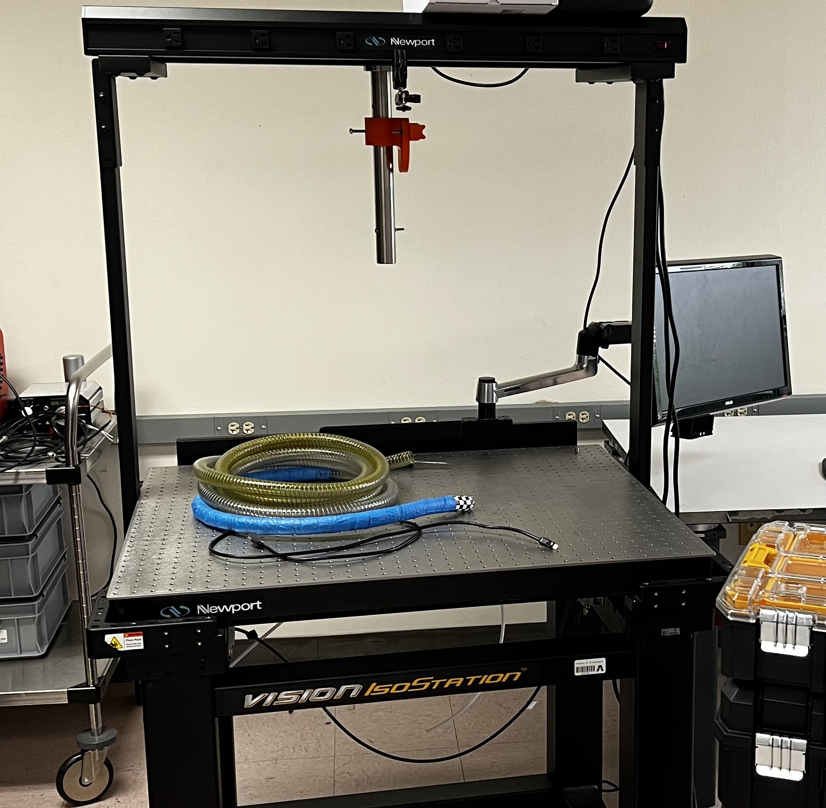***Abstract*— In recent years, the robotic manipulation of de- formable linear objects (DLOs) has gained interest among researchers, but existing datasets do not fully capture the object’s intrinsic dynamics. This work presents a novel real- world dataset that aims to capture the intrinsic dynamics and biases of DLOs or elastic rods, e.g., cables and ropes. To reduce unwanted external forces acting on the objects, we have optimized the setting, initial conditions, and tasks for low dimensional extraction of object dynamics. In addition to the dataset, we introduce a framework for configuration estimation and automatic ground truth generation.**

***Index Terms*— Deformable linear objects, dynamic dataset, manipulation**

1. INTRODUCTION

¿ [Too long, redundant phrases, add bullet point contributions]

¿ [add dataset paper structure]

¿ [add photo on first page]

In recent years, the active control of deformable objects has become a topic of interest among researchers, with applications in various industries, e.g., surgical robotics, food handling, and manufacturing [1]. Active control of deformable objects remains particularly challenging; they exhibit strong nonlinear dynamics when subject to external forces. We divide deformable objects into three main categories, 1D or linear objects, e.g., rope and cable; 2D or planar objects, e.g., paper and cloth; and deformable 3D or volumetric objects, e.g., pillows and sponges. To be more precise, we are interested in active vision applications that involve configuration estimation and control of free-hanging DLOs.

Researchers have introduced various methods to address both the perception and control tasks in applications that involve active control of DLOs, [2, 3, 4, 5]. However, the robust perception DLOs remains an open challenge for manipulation tasks. The observed shapes often suffer from false holes, missing parts, no detection in large sections, or inconsistent tracking between frames. [6] introduced a method for tracking DLOs under partial occlusion using geometric constraints. This work presents a new dataset for robotic manipulation and tracking of free-hanging DLOs. We aim to exploit primary dynamic constraints for DLO tracking in settings where the object state is dominated by its intrinsic

1. Mojra, and W.J. Beksi are with the Department of Computer Sci- ence and Engineering, The University of Texas at Arlington, Arlington, TX, USA. N.R. Gans is with The University of Texas at Arlington Re- search Institute, Fort Worth, TX, USA. Emails: [bardia.mojra@mavs.uta.edu,](mailto:bardia.mojra@mavs.uta.edu) [william.beksi@uta.edu,](mailto:william.beksi@uta.edu) [nick.g](mailto:nick.gans@uta.edu)[ans@uta.edu.](mailto:ans@uta.edu)

Fig. 1. DLO data collection setup.

dynamics rather than contact friction or other external forces.

This work aims to develop a novel dataset for configuration estimation and tracking deformable linear objects (DLOs) by enforcing dynamics constraints. Moreover, the dataset is dedicated to the robotic manipulation of free-hanging DLOs to highlight their dynamics. It contains RGBD frames, robot states, and test inputs. Additionally, we evaluate multiple DLOs with various physical and material attributes. Finally, we will discuss how robustly we can track the configuration of each DLO while enforcing fundamental dynamic constraints.

In summary, our contributions are the following.

* + Real-world dataset dedicated to learning and modeling DLO dynamics.
  + Test settings, initial conditions, and tasks are optimized to highlight the object’s intrinsic dynamics.
  + A 3D dataset with RGBD and point cloud frames with an automated DLO annotation framework.

Previous works... [briefly summarize previous work]

1. RELATED WORK

[Too long, lead to the niche we are addressing]

In recent years, manipulation and sensing of deformable objects have become a topic of interest among researchers, with applications in various industries, e.g., surgical robotics, food handling, and manufacturing [1]. Robotic manipulation

of deformable objects remains particularly challenging, as they exhibit strongly nonlinear dynamics when subject to external forces. Although researchers have successfully in- troduced various learning-based methods for manipulating DLOs, manipulating deformable objects has remained mostly manual, causing industrial and economic bottlenecks.

However, a new paradigm is emerging from data analysis and fluid dynamics research; data-driven modeling offers superior techniques for extracting explicit low-rank repre- sentations of complex systems from high-dimensional mea- surements [7, 8]. This proposal uses state-of-the-art data- driven modeling techniques to consider a framework for system identification, configuration estimation, and control of Kirchhoff elastic rods or DLOs, e.g., cables and ropes. Physics-informed dynamic mode decomposition (piDMD) and Koopman operator theory provide a promising theoreti- cal foundation in support of model predictive control (MPC) of DLOs [9, 10].

In [3], the authors formulated the problem as a fully observable Markov decision process and deployed a learning- based approach. They introduced the Canonical Visual For- ward model (CaVFM), a sample efficient method for learn- ing DLO manipulation tasks. They leverage fully-connected neural networks to preserve and learn the spatial structure of the target object.

They used self-supervised data collection and a real robot to obtain their data on 1000 manipulation episodes. In CaVFM, the authors introduce a vision-based framework for predicting and manipulating DLOs, which requires far fewer samples to train than other approaches with comparative performance. They leverage fully-convolutional networks (FCNs) to preserve spatial information throughout training and represent inputs canonically. They pair object observa- tion and displacement images at the input stage before feed- ing them to an FCN; this preserves the spatial information of both object and displacement images (translates to action input) throughout training. This is the main factor this ap- proach performs comparatively well with only 1000 training samples. They leverage a pick-and-place robotic model for its visual input space and action output space framework as they expand their capabilities to DLO manipulation.

Various approaches have been introduced for the quasi- static manipulation of DLOs, limiting manipulation tasks to low-speed movements. Bretl and McCarthy introduced a sampling-based path-planning method for dual-arm DLO manipulation tasks where grippers hold the object at both ends. They showed that a DLO in static equilibrium is a local solution to a geometric optimal control problem, the position and orientation of grippers dictate the boundary conditions. Using optimal control on manifolds and Lie-Poisson reduc- tion, they prove that the set of all equilibrium is a smooth manifold of finite dimensions. They analytically proved that DLO dynamics is a smooth left-invariant Hamiltonian system in a dual-arm configuration that can be represented explicitly in 6 dimensions using a dual-basis functions approach [11]. Although such dimensionality reduction of DLO dynamics is remarkable, this approach is strictly limited to dual-arm

configuration and slow-speed motions. Furthermore, different DLOs exhibit various degrees of elastoplasticity over differ- ent intrinsic dimensions; a systematic approach for extracting the intrinsic coherent structures from observations would offer better generalization to other DLO as it eliminates cumbersome analytical derivations. This proposal seeks a more general and systematic approach for obtaining the rank and the basis functions that are the best linear approximation of the data.

Many learning-based methods operate under a similar quasi-static assumption; they learn a discrete state-action mapping to find the optimal sequence of actions, given an initial condition and a goal state. Zhang used an auto- encoder-decoder architecture to map nonlinear states and actions to their corresponding linear latent spaces. Then, they trained a linear dynamic model in the latent space to learn the mapping between [or the latent state prior?], the latent prior state, the latent action, and the latent posterior state [8]. Although this method learns a linear operator in the latent space that successfully predicts up to 10 future states, the dynamic mapping is purely statistical, locally linear, and heavily dependent on the provided training set. Even though autoencoders are a powerful tool for dimensionality reduction, they encode input data to a specified rank and only use a polynomial basis function.

There are other deep learning methods for dual-arm and free-end DLO manipulation tasks that leverage a variety of techniques, e.g., movement primitives, model-free rein- forcement learning, constrastive learning, and dense object descriptor, but they all have similar limitations.

e.g. learning-based models [12], finite element models, and latent space models [13].

Various methods have been proposed for modeling or learning state dynamics of deformable objects [14, 13, 15, 16, 17]. However, existing methods suffer from a range of issues that make them impractical for deployment in a real-time and highly dynamic environment. These issues are attributed to the nonlinear nature of DLO dynamics and the high computational cost associated with real-time perception, high-dimensional representation, and model uncertainty mitigation techniques.

1. SETUP
2. *Physical Setup*
3. *Test Objects*

A total of four cables were used as test subjects.

1. *Software Setup*
2. *Calibration*

Something.

1. DATASET

This dataset aims to enable robotic manipulation and control of DLOs by exploiting their dynamic constraints.

1. *Sets and Episodes*
2. 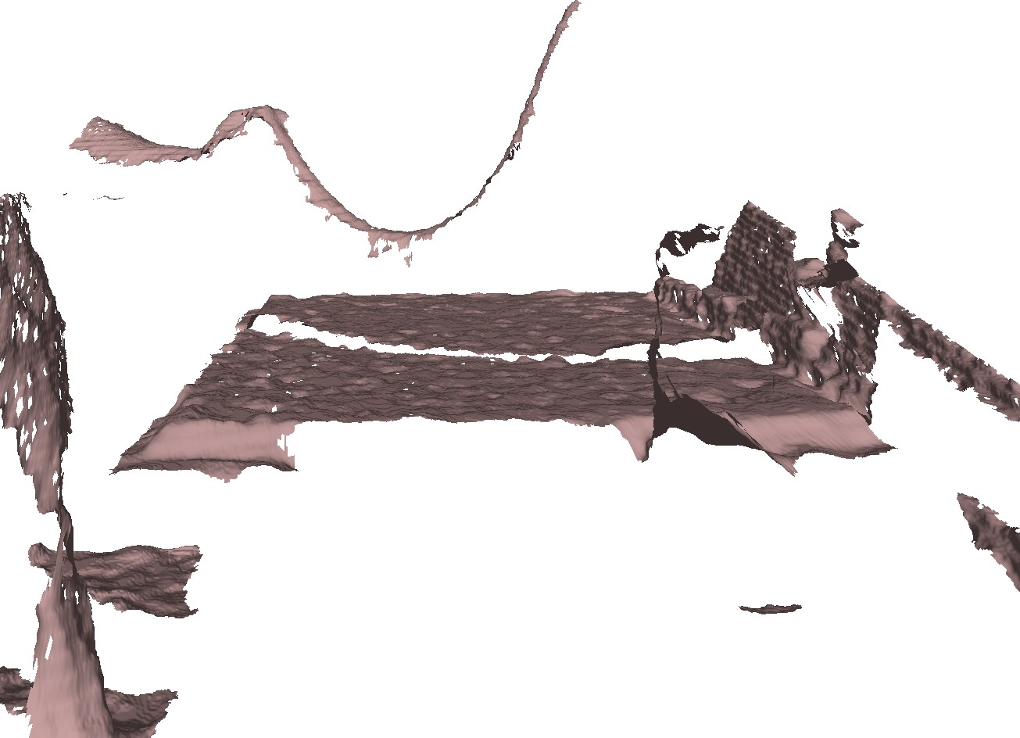*Initial Conditions*
3. *Labeling of the data*
4. *Dataset structure and content*
5. *Features*
6. *Limitations*

Fig. 2. DLO data collection setup.

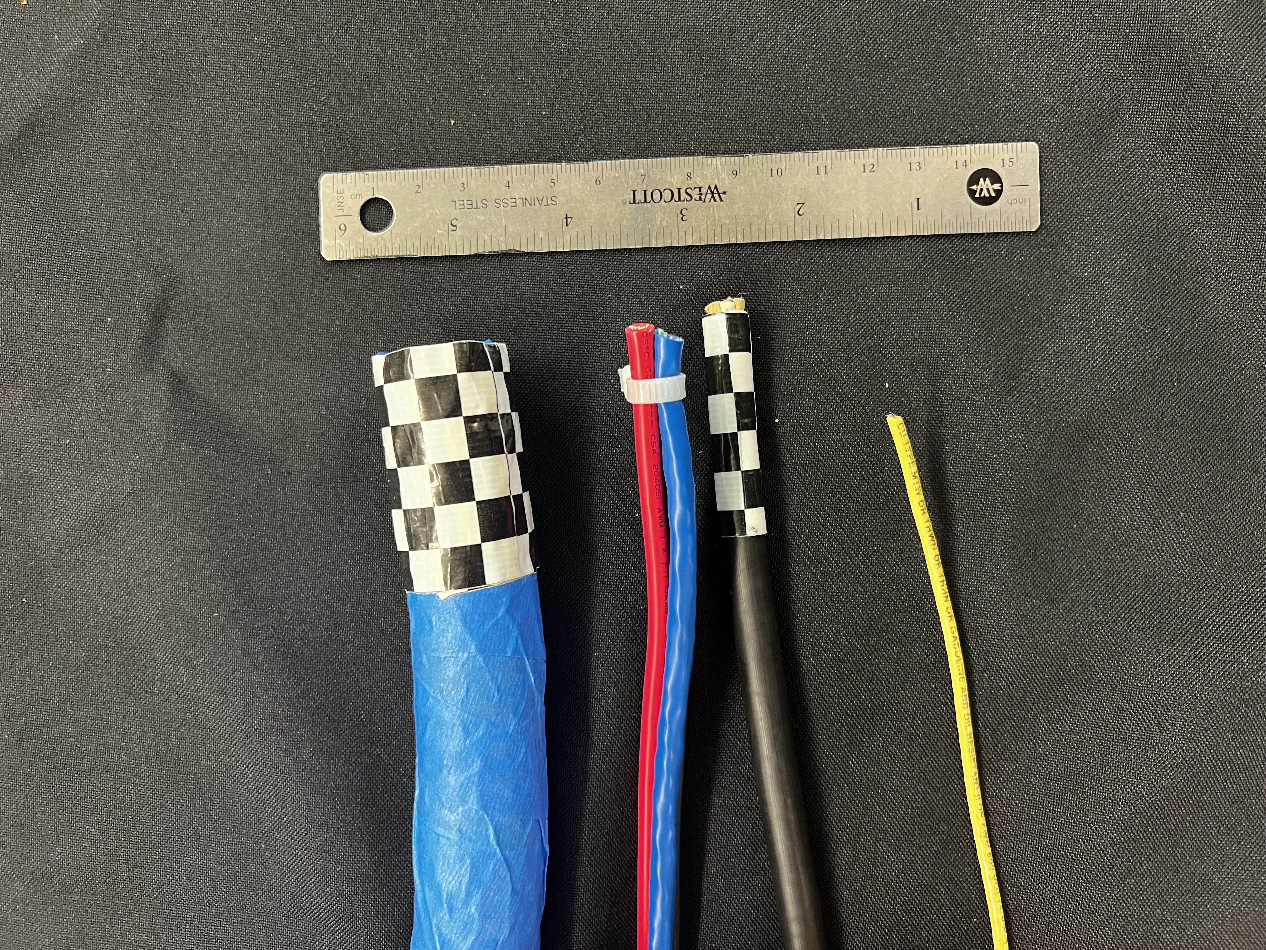

Fig. 3. Deformable linear objects.

We particularly want to extract data points representing pure object dynamics from RGBD frames.

1. *Settings*
2. *Tasks*

Table IV-B outlines five dynamic tests we designed to capture the intrinsic dynamic of DLOs.

|  |  |
| --- | --- |
| Test | Description |
| 1 | Static |
| 2 | Linear X-Axis |
| 3 | Linear Y-Axis |
| 4 | Linear Z-Axis |
| 5 | Sinusoidal X-Axis |
| 6 | Sinusoidal Y-Axis |
| 7 | Sinusoidal Z-Axis |

Table to test captions and labels.

1. APPLICATIONS
2. *Learning DLO dynamics*
3. *Modeling DLO dynamics*
4. *Untagled Learning*
5. *Koopman Operator dynamic modeling and control*

Something.

1. CONCLUSION AND FUTURE WORK REFERENCES
2. J. Sanchez, J.-A. Corrales, B.-C. Bouzgarrou, and Y. Mezouar, “Robotic manipulation and sensing of deformable objects in domestic and industrial applications: a survey,” *The International Journal of Robotics Research*, vol. 37, no. 7, pp. 688–716, 2018.
3. R. Laezza, R. Gieselmann, F. T. Pokorny, and Y. Karayiannidis, “Reform: A robot learning sandbox for deformable linear object manipulation,” in *2021 IEEE International Conference on Robotics and Automation (ICRA)*. IEEE, 2021, pp. 4717–4723.
4. R. Lee, M. Hamaya, T. Murooka, Y. Ijiri, and P. Corke, “Sample- efficient learning of deformable linear object manipulation in the real world through self-supervision,” *IEEE Robotics and Automation Letters*, vol. 7, no. 1, pp. 573–580, 2021.
5. S. Huo, A. Duan, C. Li, P. Zhou, W. Ma, H. Wang, and D. Navarro- Alarcon, “Keypoint-based planar bimanual shaping of deformable linear objects under environmental constraints with hierarchical action framework,” *IEEE Robotics and Automation Letters*, vol. 7, no. 2, pp. 5222–5229, 2022.
6. Y. Yang, J. A. Stork, and T. Stoyanov, “Online model learning for shape control of deformable linear objects,” in *2022 IEEE/RSJ International Conference on Intelligent Robots and Systems (IROS)*. IEEE, 2022, pp. 4056–4062.
7. Y. Wang, D. McConachie, and D. Berenson, “Tracking partially- occluded deformable objects while enforcing geometric constraints,” in *2021 IEEE International Conference on Robotics and Automation (ICRA)*. IEEE, 2021, pp. 14 199–14 205.
8. P. J. Schmid, “Dynamic mode decomposition of numerical and exper- imental data,” *Journal of fluid mechanics*, vol. 656, pp. 5–28, 2010.
9. M. O. Williams, I. G. Kevrekidis, and C. W. Rowley, “A data–driven approximation of the koopman operator: Extending dynamic mode decomposition,” *Journal of Nonlinear Science*, vol. 25, no. 6, pp. 1307–1346, 2015.
10. D. Bruder, X. Fu, R. B. Gillespie, C. D. Remy, and R. Vasudevan, “Data-driven control of soft robots using koopman operator theory,” *IEEE Transactions on Robotics*, vol. 37, no. 3, pp. 948–961, 2020.
11. P. J. Baddoo, B. Herrmann, B. J. McKeon, J. N. Kutz, and S. L. Brunton, “Physics-informed dynamic mode decomposition (pidmd),” *arXiv preprint arXiv:2112.04307*, 2021.
12. T. Bretl and Z. McCarthy, “Quasi-static manipulation of a kirchhoff elastic rod based on a geometric analysis of equilibrium configura- tions,” *The International Journal of Robotics Research*, vol. 33, no. 1,

pp. 48–68, 2014.

1. A. Nair, D. Chen, P. Agrawal, P. Isola, P. Abbeel, J. Malik, and

S. Levine, “Combining self-supervised learning and imitation for vision-based rope manipulation,” in *2017 IEEE international confer- ence on robotics and automation (ICRA)*. IEEE, 2017, pp. 2146–2153.

1. W. Zhang, K. Schmeckpeper, P. Chaudhari, and K. Daniilidis, “De- formable linear object prediction using locally linear latent dynamics,” in *2021 IEEE International Conference on Robotics and Automation (ICRA)*. IEEE, 2021, pp. 13 503–13 509.
2. M. Yu, H. Zhong, and X. Li, “Shape control of deformable linear objects with offline and online learning of local linear deformation models,” in *2022 International Conference on Robotics and Automa- tion (ICRA)*. IEEE, 2022, pp. 1337–1343.
3. H. Zhang, J. Ichnowski, D. Seita, J. Wang, H. Huang, and K. Goldberg, “Robots of the lost arc: Self-supervised learning to dynamically manip- ulate fixed-endpoint cables,” in *2021 IEEE International Conference on Robotics and Automation (ICRA)*. IEEE, 2021, pp. 4560–4567.
4. T. Tang, C. Wang, and M. Tomizuka, “A framework for manipulating deformable linear objects by coherent point drift,” *IEEE Robotics and Automation Letters*, vol. 3, no. 4, pp. 3426–3433, 2018.
5. F. F. Khalil and P. Payeur, *Dexterous robotic manipulation of de- formable objects with multi-sensory feedback-a review*. INTECH Open Access Publisher, 2010.